600086 Lab Book

# Week 2 – Lab 6 A simple CUDA ray caster

Date: 10th Mar 2022

## Exercise 1. Set up a virtual canvas and draw on it an image in CUDA

### Question1 :

Modify the first three values shown in make_uchar4( ) in the following line of code to draw an image of different colours, say, a green image, a grey image.

### Solution:

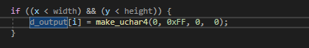

### Test data:

N/A

### Sample output:

|  |  |  |
| --- | --- | --- |
| Input | expectation | Output |
| (0, 0xFF, 0, 0) | Green |  |
| (0x45, 0xF45, 0x45, 0) | Grey |  |
| (0, 0xFF, 0, 0) | Fuchsia |  |

## Exercise 2. Drawing a checkboard in CUDA

### Question2: implement a solution using GPU processing to solve the problem

### Solution:

1. Edit the d_render( ) method to draw a checkboard

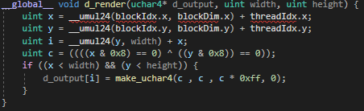

Created a new variable C which is governed by the x and y position of the pixel and applied a colour mask to it in the make_uchar4() to make the odd segments red. See Sample output ref1 for result

1. Modify the code to draw a checkboard with much larger red-blocks

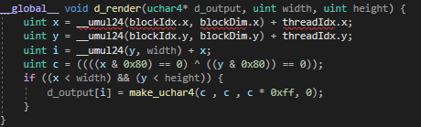

By increasing the value that x and y are multiplied by when calculating c the size of the squares in the grid can be modified I increased this to 0x80. see Sample output Ref 2 for result.

1. Further modify your code to draw a red disc in the middle of the image of a red disc:

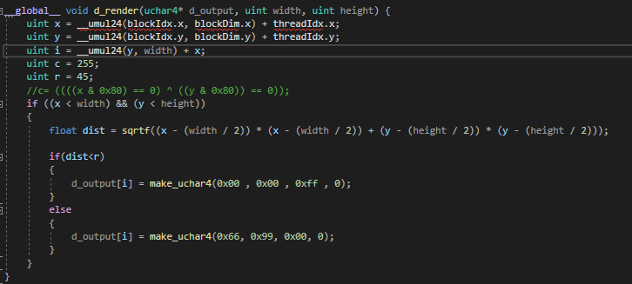

I added in a check to see if the coordinate distance of the pixel is within the range r and if so colour it red if not colour it teal. See Sample output Ref 3 for the result.

### Test data:

### Sample output:

|  |  |
| --- | --- |
| REF | Output |
| 1 |  |
| 2 |  |
| 3 |  |
|  |  |
|  |  |
|  |  |
|  |  |

### Reflection:

### Metadata:

### Further information:

## Exercise 2. Compare the performance of the CUDA solution against the CPU solution

### Question1 : Running performance test on a range of square arrays for CPU solution and GPU solution comparing the results

### Solution:

### Test data:

### Sample output:

### Reflection:

### Metadata: